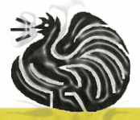 **Wauchope Poultry Club INC.**

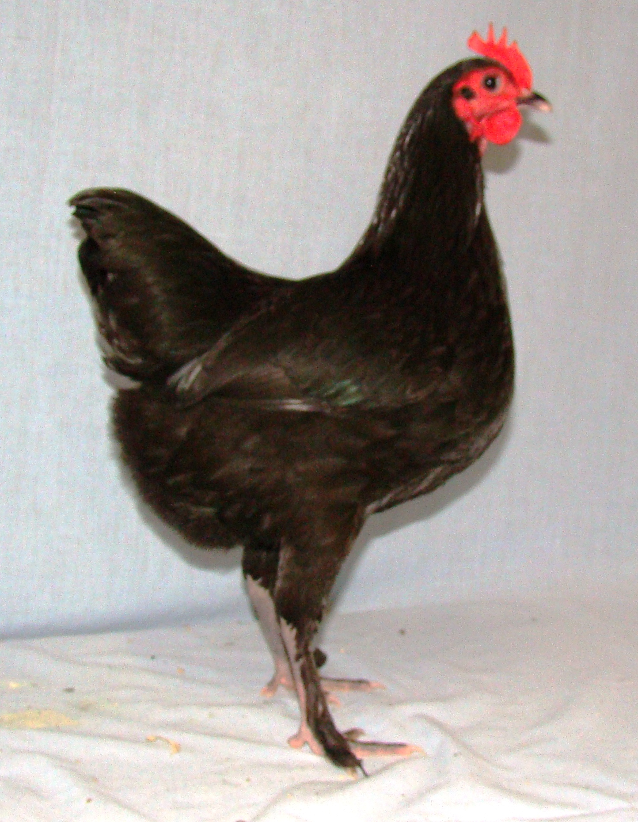

**Wauchope Poultry Club**

**INVITES YOU TO OUR**

**2024 Poultry Auction**

**Sunday 25TH August 2024 Viewing From 9:00 am Auction Starts 10:00 am**

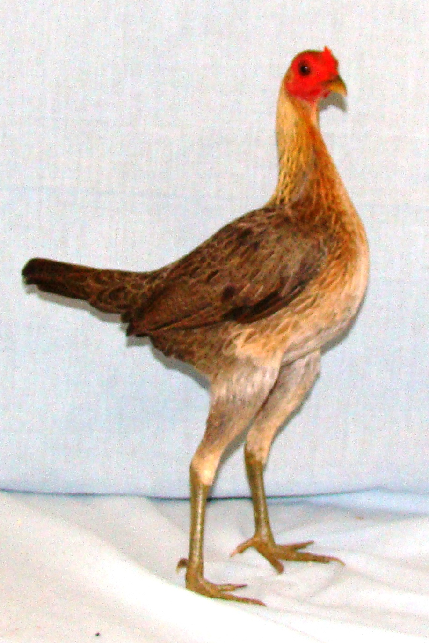

**HARLEY COOKE PAVILION, WAUCHOPE SHOWGROUND**

**HIGH STREET WAUCHOPE NSW 2446**

**Canteen Facilities Available**

**www.wauchopepoultryclub.com.au**

* **Auction Rules**
* You are invited to inspect all lots prior to the auction. Viewing begins at 9:00am (Lots can be handled with the company of a steward)
* Lots passed in may be sold by private treaty. Any such sales after the auction must be paid to the Wauchope Poultry Club Inc. and a docket must be obtained prior to the release of lots.
* The last bidder on a lot that is passed in has first offer at the reserve price.
* Lots will be offered in numerical order as listed in the catalogue
* All transactions must be STRICTLY CASH, unless prior arrangement with the Wauchope Poultry Club Inc to accept cheques.
* LOTS WILL ONLY BE RELEASED AFTER THE AUCTION. Birds will ONLY be unpenned by authorised stewards only.
* The system of bidders’ cards and numbers will be used. Please ensure you have your number prior to the commencement of the sale.
* Wauchope Poultry Club Inc accepts no responsibility for incorrect descriptions of any lots or any claims made by the vendor.
* This auction is conducted under the Constitution of By-Laws of the Wauchope Poultry Club Inc. and the usual terms of a public auction.
* All care is taken to ensure the safety of all birds and equipment, but in the event of any loss or injury, the Wauchope Poultry Club Inc. accepts no responsibility.
* Lots remain the liability of the vendor until the fall of the hammer, upon which the purchaser assumes responsibility.
* The Wauchope Poultry Club Inc. reserves the right to alter, delete or make additions to these rules as circumstances dictate.
* Minimum bid will be $5.00 per bird. $10 per pair. $15 per trio.

NOTE

* For the purpose of the catalogue, Breeding Pair and Trio’s means.ie. one male and one or two females. Otherwise, if just pair or trio means 2 or 3 Female
* Plt = Pullet
* Ckl = Cockerel
* Btm = Bantam
* RIR = Rhode Island Red (Breed)
* OEG = Old English Game (Breed)
* PB = Pullet Breeders (only Breeds Exhibition Females)
* CB = Cockerel Breeders (only Breeds Exhibition Males)

**What you need to know about our Auction-**

THIS CATALOGUE IS A GUIDE ONLY!

Lots may be changed or altered by the vendor as the catalogue is prepared and printed in advance.

Check the cage carefully as what is in the cage is what you are bidding on NOT what’s in the catalogue!

If you have any questions, please ask one of our members wearing the Wauchope Poultry Club Shirt (Red Shirts). They will be happy to help you.

If you see a sick bird, please bring it to our attention.

The Auctioneer decision is final.

Please bring your own boxes.

Lots will not be released if you have no suitable way to get them home.

No bags of any sort are to be used to transport poultry.

Please have an enjoyable day but treat our volunteers with respect.

Any abuse will not be tolerated.

| Lot | Vendor Name | Breed | Description | Price | Buyer |
| --- | --- | --- | --- | --- | --- |
| 1 | **ROD RILEY** | **AUSTRALORP** | **BLUE SPLASH PULLETS** |  |  |
| 2 | **ROD RILEY** | **PLYMOUTH ROCK** | **LARGE DARK BARRED** |  |  |
| 3 | **IAN SCHOTTE** | **AUSTRALIAN GAME** | **TRIO LARGE PILE** |  |  |
| 4 | **IAN SCHOTTE** | **MARAN** | **TRIO** |  |  |
| 5 | **JOHN MINETT** | **BARNEVELDER** | **PAIR DOUBLE LACED SILVER** |  |  |
| 7 | **JOHN MINETT** | **AUSTRALORP** | **LARGE BLACK HEN** |  |  |
| 8/9 | **BRYAN ALLEY** | **WYANDOTTE** | **BREEDING PAIR SILVER LACED**  **(TONY SHUBERT BRED)** |  |  |
| 10 | **AMANDA FLEMMING** | **MINORCA** | **TRIO BANTAMS** |  |  |
| 11 | **AMANDA FLEMMING** | **HAMBURGH** | **LARGE PAIR SILVER SPANGLED** |  |  |
| 12 | **IAN HANCOCK** | **PITT GAME** | **LARGE BLACK HENFEATHER COCK** |  |  |
| 13 | **GEOFF GRADY** | **AUSTRALIAN GAME** | **TRIO PILE BANTAM** |  |  |
| 14 | **GEOFF GRADY** | **AUSTRALIAN GAME** | **TRIO BANTAM DUCKWING** |  |  |
| 15/16 | **GARY CLARK** | **WYANDOTTE** | **LARGE PAIR WHITE (SUCCESSFULLY SHOWN GIBSON/BENSON LINE)** |  |  |
| 17 | **WENDY GRIBBLE** | **BELGIAN D’ANVER** | **BREEDING QUAD SPLASH** |  |  |
| 18 | **TIM JOHNS** | **PITT GAME** | **LARGE PAIR PLAINFACE** |  |  |
| 19 | **TIM JOHNS** | **PITT GAME** | **LARGE MUFF COCK** |  |  |
| 20 | **PHILLIP TISDELL** | **LANGSHAN** | **LARGE BREEDING PAIR**  **(SHOW QUAILITY)** |  |  |
| 21 | **IAN SCHOTTE** | **SILKIE** | **PAIR** |  |  |
| 22 | **BRYAN ALLEY** | **RHODE ISLAND** | **RED PULLET (20 WEEKS)** |  |  |
| 23/24 | **BRYAN ALLEY** | **WYANDOTTE** | **BREEDING PAIR SILVER LACED**  **(TONY SHUBERT BRED)** |  |  |
| 25 | **ROD RILEY** | **BRAHMA** | **PARTRIDGE PULLETS** |  |  |
| 26 | **ROD RILEY** | **ORPINGTON** | **BUFF PULLETS** |  |  |
| 27 | **IAN SCHOTTE** | **SILKIE** | **PAIR** |  |  |
| 28 | **BRYAN ALLEY** | **RHODE ISLAND** | **RED PULLET (20 WEEKS)** |  |  |
| 29/30 | **PHILLIP TISDELL** | **AUSTRALORP** | **LARGE BREEDING PAIR**  **(SHOW QUAILITY)** |  |  |
| 31 | **LINCOLN EMMS** | **LEGHORN** | **LARGE WHITE PAIR PULLETS**  **(OF QUAILTY.**  **L. EMMS SHOW WINNING STRAIN)** |  |  |
| 32 | **LINCOLN EMMS** | **LANGSHAN** | **LARGE BLACK PAIR PULLETS**  **(TOP SHOW QUAILTY.**  **L. EMMS SHOW WINNING STRAIN)** |  |  |
| 33 | **AMANDA FLEMMING** | **BARNEVELDER** | **BANTAM PAIR** |  |  |
| 34 | **AMANDA FLEMMING** | **WYANDOTTE** | **BANTAM PAIR SILVER PENCILLED** |  |  |
| 35 | **JOHN MINETT** | **BARNEVELDER** | **LARGE SILVER DOUBLE LACED ROOSTER** |  |  |
| 36 | **JOHN MINETT** | **BARNEVELDER** | **LARGE SILVER DOUBLE LACED HEN** |  |  |
| 37 | **IAN SCHOTTE** | **POLISH** | **PAIR SILVER LACED** |  |  |
| 38 | **IAN SCHOTTE** | **POLISH** | **PAIR SILVER LACED** |  |  |
| 39 | **LINCOLN EMMS** | **OLD ENGLISH GAME** | **BANTAM TRIO GINGER PILE (OUTSTANDING QUAILITY. WINNERS OF MAJOR AWARDS. L.EMMS STRAIN)** |  |  |
| 40/41 | **GARY CLARK** | **WYANDOTTE** | **LARGE PAIR WHITE**  **SUCCESSFULLY SHOWN**  **GIBSON/BENSON LINE)** |  |  |
| 42 | **ROD RILEY** | **BRAHMA** | **PARTRIDGE PULLETS** |  |  |
| 43 | **ROD RILEY** | **PEKIN** | **BANTAM PAIR WHITE PULLETS (PETER SMITH BREEDER)** |  |  |
| 44 | **GEOFF GRADY** | **AUSTRAILIAN GAME** | **LARGE PAIR PILE HENS** |  |  |
| 45 | **JOHN MINETT** | **AUSTRALORP** | **LARGE BLACK HEN** |  |  |
| 46 | **JOHN MINETT** | **AUSTRALORP** | **LARGE BLUE HEN** |  |  |
| 47 | **IAN SCHOTTE** | **SILKIE** | **PAIR** |  |  |
| 48 | **IAN SCHOTTE** | **SILKIE** | **PAIR** |  |  |
| 49 | **GEOFF GRADY** | **AUSTRALIAN GAME** | **TRIO PILE** |  |  |
| 50 | **ROD RILEY** | **PEKIN** | **BANTAM PAIR WHITE PULLETS (PETER SMITH BREEDER)** |  |  |
| 51 | **ROD RILEY** | **WYANDOTTE** | **GOLD LACED PULLETS** |  |  |
| 52 | **JOHN MINETT** | **AUSTRALORP** | **LARGE BLACK ROOSTER** |  |  |
| 53 | **JOHN MINETT** | **AUSTRALORP** | **LARGE BLACK HEN** |  |  |
| 54 | **JOHN MINETT** | **AUSTRALORP** | **LARGE BLUE HEN** |  |  |
| 55/56 | **GARY CLARK** | **WYANDOTTE** | **LARGE PAIR WHITE**  **(SUCCESSFULLY SHOWN GIBSON/BENSON LINE)** |  |  |
| 57 | **LINCOLN EMMS** | **OLD ENGLISH GAME** | **BANTAM TRIO GINGER PILE (OUTSTANDING QUAILITY. WINNERS OF MAJOR AWARDS. L.EMMS STRAIN)** |  |  |
| 58/59 | **BRYAN ALLEY** | **WYANDOTTE** | **BREEDING PAIR BLUE GOLD LACED** |  |  |
| 60 | **BRYAN ALLEY** | **AUSTRALORP** | **1 BLACK & 1 BLUE PULLETS (16 WEEKS)** |  |  |
| 61 | **GEOFF GRADY** | **AUSTRALIAN GAME** | **BANTAM TRIO BLACK RED** |  |  |
| 62 | **LINCOLN EMMS** | **OLD ENGLISH GAME** | **BANTAM PAIR GINGER DUCKWING (OF STRIKING COLOUR)** |  |  |
| 63 | **IAN HANCOCK** | **PITT GAME** | **LARGE BLACK HENFEATHER COCKEREL** |  |  |
| 64 | **IAN SCHOTTE** | **PEKIN** | **PAIR BLACK** |  |  |
| 65/66 | **IAN SCHOTTE** | **WYANDOTTE** | **PAIR PARTRIDGE** |  |  |
| 67 | **GEOFF GRADY** | **AUSTRALIAN GAME** | **BANTAM TRIO BLACK RED** |  |  |
| 68 | **JOHN MINETT** | **AUSTRALORP** | **LARGE BLUE ROOSTER** |  |  |
| 69 | **JOHN MINETT** | **AUSTRALORP** | **LARGE BLACK PULLET** |  |  |
| 70 | **JOHN MINETT** | **AUSTRALORP** | **LARGE BLUE PULLET** |  |  |
| 71 | **ROD RILEY** | **WYANDOTTE** | **BLUE RED LACED PULLETS** |  |  |
| 72 | **ROD RILEY** | **WYANDOTTE** | **GOLD LACED PULLETS** |  |  |
| 73 | **IAN HANCOCK** | **PITT GAME** | **LARGE BLACK HENFEATHER COCKEREL** |  |  |
| 74 | **BRYAN ALLEY** | **SUSSEX** | **LIGHT PULLET (20 WEEKS)** |  |  |
| 75 | **BRYAN ALLEY** | **SUSSEX** | **LIGHT PULLET (20 WEEKS)** |  |  |
| 76/77 | **BRYAN ALLEY** | **WYANDOTTE** | **BREEDING PAIR BLUR GOLD LACED** |  |  |
| 78 | **LISA PARRY** | **OLD ENGLISH GAME** | **BANTAM TRIO 1 TASSELLED WHEATEN PULLET, 1 WHEATEN PULLET, 1BLUE RED COCKEREL** |  |  |
| 79 | **LISA PARRY** | **PEKIN** | **LEMON COCKEREL** |  |  |
| 80 | **IAN SCHOTTE** | **JAP** | **QUAIL TRIO** |  |  |
| 81/82 | **RUBY WEISMANTEL** | **SUSSEX** | **LARGE TRIO SPECKLED** |  |  |
| 83 | **BRYAN ALLEY** | **AUSTRALORP** | **PULLET (20 WEEKS)** |  |  |
| 84 | **BRYAN ALLEY** | **AUSTRALORP** | **PULLET (20 WEEKS)** |  |  |
| 85 | **DWAYNE KELLY** | **AUSTRALIAN GAME** | **LARGE COCKEREL** |  |  |
| 86 | **JOHN MINETT** | **AUSTRALORP** | **LARGE BLUE ROOSTER** |  |  |
| 87 | **JOHN MINETT** | **AUSTRALORP** | **LARGE BLUE PULLET** |  |  |
| 88 | **JOHN MINETT** | **AUSTRALORP** | **LARGE SPLASH HEN** |  |  |
| 89 | **LISA PARRY** | **OLD ENGLISH GAME** | **BANTAM PAIR BLUE TAILED WHEATEN PULLET & BLUE RED COCKEREL** |  |  |
| 90 | **IAN SCHOTTE** | **BARNEVELDER** | **PAIR** |  |  |
| 91 | **IAN SCHOTTE** | **JAP** | **QUAIL TRIO** |  |  |
| 92 | **GILLIAN VOLKEN** | **AUSTRALORP** | **LARGE BLUE PULLET (14 WEEKS)** |  |  |
| 93 | **BRYAN ALLEY** | **DORKING** | **BREEDING PAIR SILVER** |  |  |
| 94 | **ROD RILEY** | **WYANDOTTE** | **BLUE RED LACED PULLETS** |  |  |
| 95 | **ROD RILEY** | **WYANDOTTE** | **SILVER LACED PULLETS** |  |  |
| 96 | **DWAYNE KELLY** | **OLD ENGLISH GAME** | **BANTAM TRIO PILE** |  |  |
| 97 | **BRYAN ALLEY** | **WYANDOTTE** | **SILVER LACED COCKEREL**  **(24 WEEKS) TONY SHURBERT BRED** |  |  |
| 98 | **DWAYNE KELLY** | **AUSTRALIAN GAME** | **LARGE COCKEREL** |  |  |
| 99 | **GILLIAN VOLKEN** | **AUSTRALORP** | **LARGE BLACK HEN** |  |  |
| 100 | **BRYAN ALLEY** | **RHODE ISLAND** | **WHITE HEN (2ND LAY)** |  |  |
| 101 | **RUBY WEISMANTEL** | **SUSSEX** | **LARGE PAIR SPECKLED** |  |  |
| 102 | **DWAYNE KELLY** | **OLD ENGLISH GAME** | **BANTAM TRIO WHEATEN BLUETAIL** |  |  |
| 103 | **DWAYNE KELLY** | **OLD ENGLISH GAME** | **BANTAM TRIO BLACK RED WHEATEN** |  |  |
| 104 | **ROD RILEY** | **WYANDOTTE** | **BLUE RED LACED PULLETS** |  |  |
| 105 | **ROD RILEY** | **WYANDOTTE** | **GOLD LACED PULLETS** |  |  |
| 106 | **IAN MC GOLDRICK** | **AUSTRALIAN GAME** | **BANTAM TRIO PILE** |  |  |
| 107 | **BRYAN ALLEY** | **WYANDOTTE** | **SILVER LACED COCKEREL**  **(24 WEEKS) TONY SHURBERT BRED** |  |  |
| 108 | **DWAYNE KELLY** | **OLD ENGLISH GAME** | **BANTAM TRIO DUCKWING** |  |  |
| 109 | **IAN MC GOLDRICK** | **AUSTRALIAN GAME** | **LARGE PILE MALE** |  |  |
| 110 | **TRUDI DURDA** | **PLYMOUTH ROCK** | **BREEDING PAIR DARK BARRED (PROVEN BREEDER)** |  |  |
| 111 | **IAN MC GOLDRICK** | **AUSTRALIAN GAME** | **BANTAM TRIO PILE** |  |  |
| 112 | **IAN MC GOLDRICK** | **AUSTRALIAN GAME** | **LARGE PAIR** |  |  |
| 113 | **TRUDI DURDA** | **PLYMOUTH ROCK** | **PAIR HENS DARK BARRED** |  |  |
| 114 | **ROD RILEY** | **WYANDOTTE** | **RED BLUE LACED PULLETS** |  |  |
| 115 | **ROD RILEY** | **WYANDOTTE** | **SILVER LACED PULLETS** |  |  |
| 116 | **CATHY CHAMBERS** | **BRAHMA** | **PAIR WHITE (YOUNG)** |  |  |
| 117 | **IAN MC GOLDRICK** | **AUSTRALIAN GAME** | **BANTAM TRIO PILE** |  |  |
| 118 | **IAN MC GOLDRICK** | **AUSTRALIAN GAME** | **LARGE PAIR** |  |  |
| 119 | **BRYAN ALLEY** | **PLYMOUTH ROCK** | **DARK BARRED COCKEREL (24 WEEKS)**  **TOP QUAILITY** |  |  |
| 120 | **BRYAN ALLEY** | **PLYMOUTH ROCK** | **LIGHT BARRED COCKEREL (24 WEEKS)**  **TOP QUAILITY** |  |  |
| 121 | **TAYLA DICKINSON** | **FRIZZLE** | **LARGE HEN (LAYING)** |  |  |
| 122 | **RUBY WEISMANTEL** | **SUSSEX** | **LARGE LIGHT COCKEREL** |  |  |
| 123 | **ROD RILEY** | **WYANDOTTE** | **SILVER LACED PULLETS** |  |  |
| 124 | **ROD RILEY** | **WYANDOTTE** | **BLACK PULLETS** |  |  |
| 125 | **CATHY CHAMBERS** | **BRAHMA** | **PAIR WHITE (YOUNG)** |  |  |
| 126 | **BRYAN ALLEY** | **DORKING** | **BREEDING PAIR SILVER** |  |  |
| 127 | **CATHY CHAMBERS** | **LEGBAR** | **TRIO CREAM 1 MALE**  **(2 FEMALES POINT OF LAY)** |  |  |
| 128 | **CATHY CHAMBERS** | **BRAHMA** | **HEN SALMON** |  |  |
| 129 | **DWAYNE KELLY** | **OLD ENGLISH GAME** | **BANTAM TRIO DUCKWING** |  |  |
| 130 | **KAREN MARRIOTT** | **SUSSEX** | **CORINATION COCKEREL**  **(SHOW QUAILTY)** |  |  |
| 131 | **TERRY MC CUSKER** | **PEKIN** | **BANTAMS BREEDING TRIO BUFF** |  |  |
| 132 | **TERRY MC CUSKER** | **PEKIN** | **BANTAMS TRIO MOTTLED FURNACE** |  |  |
| 133/134 | **ROD RILEY** | **AUSTRALORP** | **LARGE TRIO BLACK** |  |  |
| 135 | **TERRY MC CUSKER** | **ANCONA** | **LARGE BREEDING PAIR RED** |  |  |
| 136 | **ROD RILEY** | **ORPINGTON** | **PAIR BLACK** |  |  |
| 137/138 | **ROD RILEY** | **AUSTRALORP** | **LARGE TRIO BLACK** |  |  |
| 139 | **CLAYTON FINLAY** | **AUSTRALIAN GAME** | **LARGE PAIR PILE** |  |  |
| 140 | **CLAYTON FINLAY** | **PLYMOUTH ROCK** | **BANTAM PAIR DARK BARRED** |  |  |
| 141 | **ROD RILEY** | **RHODE ISLAND** | **PAIR RED - ROSECOMB** |  |  |
| 142 | **ROD RILEY** | **RHODE ISLAND** | **WHITE PULLETS - ROSECOMB** |  |  |
| 143 | **CLAYTON FINLAY** | **AUSTRALIAN GAME** | **LARGE PAIR PILE** |  |  |
| 144/145 | **ROD RILEY** | **RHODE ISLAND** | **TRIO RED** |  |  |
| 146/147 | **ROD RILEY** | **SUSSEX** | **LARGE TRIO** |  |  |
| 148 | **AMANDA FLEMMING** | **MINORCA** | **BANTAM PAIR PULLETS** |  |  |
| 149 | **DR HARRY COOPER** | **POLISH** | **BANTAM PAIR** |  |  |
| 150 | **BRYAN ALLEY** | **HAMBURGH** | **SILVER SPANGLED COCKEREL**  **(24 WEEKS)** |  |  |
| 151 | **BRYAN ALLEY** | **RHODE ISLAND** | **RED PULLET (20 WEEKS)** |  |  |
| 152 | **BRYAN ALLEY** | **RHODE ISLAND** | **RED PULLET (20 WEEKS)** |  |  |
| 153 | **ROD RILEY** | **RHODE ISLAND** | **WHITE PULLETS** |  |  |
| 154 | **ROD RILEY** | **RHODE ISLAND** | **WHITE PULLETS** |  |  |
| 155 | **DR HARRY COOPER** | **POLISH** | **BANTAM PAIR** |  |  |
| 156 | **BRIANNA CLARKE** | **AUSTRALIAN GAME** | **GINGER PILE ROOSTER** |  |  |
| 157 | **DR HARRY COOPER** | **POLISH** | **BANTAM PAIR** |  |  |
| 158 | **DR HARRY COOPER** | **POLISH** | **BANTAM PAIR** |  |  |
| 159 | **BRYAN ALLEY** | **RHODE ISLAND** | **RED COCKEREL (24 WEEKS)** |  |  |
| 160 | **AMANDA DARCY** | **PEKIN** | **TRIO MEALY GREY** |  |  |
| 161 | **ROD RILEY** | **SUSSEX** | **PULLETS** |  |  |
| 162 | **ROD RILEY** | **SUSSEX** | **PULLETS** |  |  |
| 163 | **BRIANNA CLARKE** | **BRAHMA** | **BLUE PARTRIDGE COCKEREL** |  |  |
| 164 | **JAMES TAIT** | **SILKIE** | **2 PULLETS** |  |  |
| 165 | **JAMES TAIT** | **SILKIE** | **PULLET** |  |  |
| 166 | **ROBERT MC KENZIE** | **LEGHORN** | **BLUE ROOSTER** |  |  |
| 167 | **ROBERT MC KENZIE** | **LEGHORN** | **BLUE HEN** |  |  |
| 168 | **ROBERT MC KENZIE** | **LEGHORN** | **PAIR BLUE PULLETS** |  |  |
| 169 | **AMANDA DARCY** | **PEKIN** | **TRIO MEALY GREY** |  |  |
| 170 | **AMANDA DARCY** | **PEKIN** | **PAIR MEALY GREY** |  |  |
| 171 | **ROD RILEY** | **RHODE ISLAND** | **WHITE PULLETS** |  |  |
| 172 | **ROD RILEY** | **RHODE ISLAND** | **WHITE PULLETS** |  |  |
| 173 | **TENEALE MITCHELL** | **PEKIN** | **PAIR BUFF HENS** |  |  |
| 174 | **CATHY CHAMBERS** | **ORPINGTON** | **BUFF ROOSTER** |  |  |
| 175 | **CATHY CHAMBERS** | **ORPINGTON** | **BUFF ROOSTER** |  |  |
| 176 | **TENEALE MITCHELL** | **PEKIN** | **TRIO BUFF** |  |  |
|  |  |  |  |  |  |
| BTM 1 | **WENDY GRIBBLE** | **BELGIAN D’ANVERS** | **BREEDING TRIO BLACK** |  |  |
| BTM 2 | **AMANDA FLEMMING** | **ANCONA** | **BANTAM PAIR** |  |  |
| BTM 3 | **STAN MILLS** | **BELGIAN D’UCCLE** | **TRIO SILVER MILLEFLEUR** |  |  |
| BTM 4 | **STAN MILLS** | **BELGIAN D’UCCLE** | **TRIO SILVER MILLEFLEUR PULLETS** |  |  |
| BTM 5 | **BRYAN ALLEY** | **WYANDOTTE** | **BANTAM WHITE HEN (2ND LAY)** |  |  |
| BTM 6 | **WENDY GRIBBLE** | **BELGIAN D’ANVERS** | **BREEDING TRIO BLACK/MOTTLED** |  |  |
| BTM 7 | **AMANDA FLEMMING** | **ANCONA** | **BANTAM PAIR** |  |  |
| BTM 8 | **STAN MILLS** | **BELGIAN D’UCCLE** | **MILLEFLEURS HEN (2YEARS OLD)** |  |  |
| BTM 9 | **AMANDA FLEMMING** | **ANCONA** | **BANTAM PAIR** |  |  |
| BTM 10 | **WENDY GRIBBLE** | **BELGIAN D’ANVERS** | **BREEDING TRIO QUAIL** |  |  |
| BTM 11 | **WENDY GRIBBLE** | **BELGIAN D’ANVERS** | **2 BLUE QUAIL PULLETS** |  |  |
| BTM 12 | **AMANDA FLEMMING** | **AUSTRALIAN GAME** | **BANTAM PAIR PILE** |  |  |
| BTM 13 | **IAN SCHOTTE** | **BELGIAN** | **PAIR** |  |  |
| BTM 14 | **BRYAN ALLEY** | **WYANDOTTE** | **BANTAM PARTRIDGE COCKEREL PULLET BREEDER (24 WEEKS)** |  |  |
| BTM 15 | **AMANDA FLEMMING** | **ANCONA** | **BANTAM PAIR** |  |  |
| BTM 16 | **STAN MILLS** | **BELGIAN D’UCCLE** | **TRIO SILVER MILLEFLEUR** |  |  |
| BTM 17 | **DWAYNE KELLY** | **MODERN GAME** | **BANTAM SILVER DUCKWING** |  |  |
| BTM 18 | **DEB COOKE** | **SUSSEX** | **BANTAM BLACK COCKERELTAYLA DICKINSON** |  |  |
| BTM 19 | **TAYLA DICKINSON** | **ARAUCANA** | **BANTAM ROOSTER** |  |  |
| BTM 20 | **TENEALE MITCHELL** | **PEKIN** | **SPLASH HEN** |  |  |
| BTM 21 | **TENEALE MITCHELL** | **PEKIN** | **BLUE COCKEREL (YOUNG)** |  |  |
| BTM 22 | **TENEALE MITCHELL** | **PEKIN** | **10 CHICKS** |  |  |
| BTM 23 | **CATHY CHAMBERS** |  | **QUAIL 10X** |  |  |
| BTM 24 | **AMANDA DARCY** | **SILKIE** | **SPLASH ROOSTER** |  |  |
| BTM 25 | **AMANDA DARCY** | **SILKIE** | **PARTRIDGE ROOSTER** |  |  |
| BTM 26 | **AMANDA DARCY** | **SILKIE** | **PULLET** |  |  |
|  |  |  |  |  |  |
| 177 | **IAN SCHOTTE** | **PHEASANT** | **PAIR GOLDEN** |  |  |
| 178 | **IAN SCHOTTE** | **PHEASANT** | **LADY AMHERT COCK** |  |  |
| 179 | **IAN SCHOTTE** | **PHEASANT** | **RINGNECK COCK** |  |  |
| 180 | **IAN SCHOTTE** | **GUINEA FOWL** | **TRIO** |  |  |
| 181 | **IAN SCHOTTE** | **GUINEA FOWL** | **TRIO** |  |  |
| 182 | **IAN SCHOTTE** | **GUINEA FOWL** | **TRIO** |  |  |
| 183 | **ROD RILEY** | **WATERFOWL** | **PAIR CALL** |  |  |
| 184 | **ROD RILEY** | **WATERFOWL** | **PAIR CALL** |  |  |
| 185 | **TERRY MC CUSKER** | **WATERFOWL** | **BREEDIING PAIR BLACK BIB CALL** |  |  |
| 186 | **AMANDA FLEMMING** | **WATERFOWL** | **PAIR CALL** |  |  |
| 187 | **AMANDA FLEMMING** | **WATERFOWL** | **TRIO WHITE MALLARD** |  |  |
| 188 | **IAN SCHOTTE** | **WATERFOWL** | **PAIR MUSCOVIES** |  |  |
| 189 | **IAN SCHOTTE** | **WATERFOWL** | **PAIR MUSCOVIES** |  |  |
| 190 | **AMANDA FLEMMING** | **WATERFOWL** | **PAIR MUSCOVIES** |  |  |
| 191 | **AMANDA FLEMMING** | **WATERFOWL** | **BANTAM PAIR SILVER APPLEYARD** |  |  |
| 192 | **AMANDA FLEMMING** | **WATERFOWL** | **BANTAM PAIR SILVER APPLEYARD** |  |  |
| 193 | **AMANDA FLEMMING** | **WATERFOWL** | **BANTAM PAIR SILVER APPLEYARD** |  |  |
| 194 | **AMANDA FLEMMING** | **WATERFOWL** | **BANTAM PAIR SILVER APPLEYARD** |  |  |
| 195 | **TAYLA DICKINSON** | **WATERFOWL** | **BREEDING PAIR MUSCOVIES**  **(GOOD QUAILTY)** |  |  |
| 196 | **TERRY MC CUSKER** | **WATERFOWL** | **BREEDING PAIR WHITE CALL** |  |  |
| 197 | **TAYLA DICKINSON** | **WATERFOWL** | **PAIR FEMALE MUSCOVIES**  **(GOOD QUAILTY)** |  |  |
| 198 | **AMANDA FLEMMING** | **WATERFOWL** | **PAIR MUSCOVIES** |  |  |
| 199 | **AMANDA FLEMMING** | **WATERFOWL** | **PAIR MUSCOVIES** |  |  |
| 200/201 | **IAN SCHOTTE** | **TURKEY** | **PAIR** |  |  |
| 202 | **CHRISTOPHER CALLER** | **MUSCOVY** | **FEMALE** |  |  |
| 203 | **CHRISTOPHER CALLER** | **MUSCOVY** | **FEMALE** |  |  |
| 204 | **CHRISTOPHER CALLER** | **MUSCOVY** | **FEMALE** |  |  |
| 205 | **CHRISTOPHER CALLER** | **MUSCOVY** | **FEMALE** |  |  |
| 206 | **CHRISTOPHER CALLER** | **MUSCOVY** | **FEMALE** |  |  |
| 207 | **DR HARRY COOPER** | **WATERFOWL** | **GEESE** |  |  |
| 208 | **DR HARRY COOPER** | **WATERFOWL** | **GEESE** |  |  |
| 209 | **DR HARRY COOPER** | **WATERFOWL** | **GEESE** |  |  |
| 210 | **DR HARRY COOPER** | **WATERFOWL** | **GEESE** |  |  |
| 211 | **DR HARRY COOPER** | **WATERFOWL** | **GEESE** |  |  |
| 213 | **DR HARRY COOPER** | **WATERFOWL** | **GEESE** |  |  |
| 214 | **DR HARRY COOPER** | **WATERFOWL** | **GEESE** |  |  |
|  |  |  |  |  |  |
| A | **JOHN MINETT** | **AUSTRALORP** | **1 DOZEN FERTILISED EGGS** |  |  |
| B | **JOHN MINETT** | **AUSTRALORP** | **1 DOZEN FERTILISED EGGS** |  |  |
| C | **JOHN MINETT** | **AUSTRALORP** | **1 DOZEN FERTILISED EGGS** |  |  |
| D | **JOHN MINETT** | **AUSTRALORP** | **1 DOZEN FERTILISED EGGS** |  |  |
| E | **BRYAN ALLEY** | **HAMBURGH** | **1 DOZEN FERTILISED EGGS (SILVER SPANGLED)** |  |  |
| F | **BRYAN ALLEY** | **SUSSEX** | **1 DOZEN FERTILISED EGGS (LIGHT)** |  |  |
| G | **BRYAN ALLEY** | **WYANDOTTE** | **1 DOZEN FERTILISED EGGS (SILVERLACED. TONY SHUBERT LINE)** |  |  |
| H | **GEOFF GRADY** | **CARRY BOX** | **BANTAM 2 COMPARTMENT** |  |  |
| I | **GEOFF GRADY** | **CARRY BOX** | **BANTAM 2 COMPARTMENT** |  |  |
| J | **GEOFF GRADY** | **CARRY BOX** | **BANTAM 2 COMPARTMENT** |  |  |
| K | **GEOFF GRADY** | **CARRY BOX** | **LARGE 1 COMPARTMENT** |  |  |
| L | **GEOFF GRADY** | **CARRY BOX** | **LARGE 1 COMPARTMENT** |  |  |
| M | **GEOFF GRADY** | **CARRY BOX** | **LARGE 1 COMPARTMENT** |  |  |
| N | **GEOFF GRADY** | **CARRY BOX** | **LARGE 2 COMPARTMENT** |  |  |
| O | **DWAYNE KELLY** | **SHOW BOX** |  |  |  |
| P | **DWAYNE KELLY** | **SHOW BOX** |  |  |  |
| Q | **DWAYNE KELLY** | **SHOW BOX** |  |  |  |
| R | **DWAYNE KELLY** | **SHOW BOX** |  |  |  |
| S | **DWAYNE KELLY** | **SHOW BOX** |  |  |  |
| T | **KAREN MARRIOTT** | **CARRY CAGE** | **BRAND NEW** |  |  |
| U | **KAREN MARRIOTT** | **CARRY CAGE** | **ALMOST BRAND NEW X2** |  |  |
| V | **KAREN MARRIOTT** | **TRAP** |  |  |  |
| W | **KAREN MARRIOTT** | **CARRY CAGE** | **USED X3** |  |  |
| X | **TERRY** | **CARRY CAGE** | **DOG WIRER CONSTRUTION** |  |  |
| Y | **KAREN MARRIOTT** | **WIRER** | **APPROX. 15M** |  |  |
| Z | **ROD RILEY** | **CARRY BOXES** |  |  |  |
|  | **ROD RILEY** | **CAGES** |  |  |  |
|  |  |  |  |  |  |
| AA | **TENEALE MITCHELL** | **PEKIN** | **1 DOZEN FERTILISED EGGS BUFF** |  |  |
| AB | **TENEALE MITCHELL** | **PEKIN** | **1 DOZEN FERTILISED EGGS BUFF** |  |  |
| AC | **TENEALE MITCHELL** | **PEKIN** | **1 DOZEN FERTILISED EGGS**  **BLUE LAVENDER** |  |  |
| AD | **TENEALE MITCHELL** | **PEKIN** | **1 DOZEN FERTILISED EGGS**  **BLUE LAVENDER** |  |  |
| AE | **TENEALE MITCHELL** | **PEKIN** | **1 DOZEN FERTILISED EGGS**  **GOLD LACED** |  |  |
| AF | **CATHY CHAMBERS** | **ORPINGTON** | **1 DOEN FERTILISED EGGS**  **BUFF** |  |  |
| AG | **CATHY CHAMBERS** | **LEGBAR** | **1 DOZEN FERTILISED EGGS**  **CREAM** |  |  |
| AH | **TERRY** | **WIRER** | **ROLL AVERY (NEVER USED)** |  |  |
| AI | **GREG MILLIGAN** | **CARRY BBOX** | **BANTAM 3 COMPARTMENT** |  |  |
| AJ | **EMILY DAVIS** | **SEBRIGHT** | **1 DOZEN FERTILISED EGGS**  **GOLD** |  |  |
| AK | **EMILY DAVIS** | **POLISH** | **1 DOZEN FERTILISED EGGS**  **(SMOOTH & FRIZZLE) GOLD & SILVER** |  |  |
| AL | **LISA PARRY** | **AUSTRALORP** | **1 DOZEN FERTILISED EGGS** |  |  |
| AM | **LISA PARRY** | **SUSSEX** | **1 DOZEN FERTILISED EGGS**  **LIGHT** |  |  |
| AN | **LISA PARRY** | **HAMBURGH** | **1 DOZEN MIXED GOLD BLACK AND GOLD WHITE SPANGLED** |  |  |